

DLD Lab-09
Multiplexer & De Multiplexer


NATIONAL UNIVERSTIY OF COMPUTER AND EMERGING SCIENCES, FAST- Peshawar Campus
Department Of Computer Science
EL1005 – Digital Logic Design-Lab
SEMESTER SPRING 2026

Contents
1. Objectives: 2
2. Equipment Required: 2
3. Background Theory 2
4. 4x1 Mux Contd. 3
5. 4x1 Mux(74LS153 Testing in Multisim) 4
6. 8x1 Mux 4
7. 8x1 Mux(74LS151 Testing in Multisim) 5
8. DE Multiplexer 6
9. 1x4 De Multiplexer 6
10. 1x4 De-Mux(74LS139 Testing in Multisim) 7
11. 1x8 De Multiplexer 8

Objectives:
- Design and implement the circuitry for a 4 to 1 Multiplexer.
- Test the functionality of a 1x4 DE multiplexer using the IC-74LS139
- Test the functionality of a 8x1 multiplexer using the IC-74LS151
- Test the functionality of a 4x1 multiplexer using the IC-74LS153Gaining a close insight into the functioning and properties of multiplexer (MUX) circuits
- Developing skills in the design and testing of combinational logic circuits.

Equipment Required:
- DEV-2765E Trainer Board/ Multisim 14.2 /Logic.ly
- 74LS04 Hex Inverter
- 74LS08 And gate
- 74LS32 OR gate
- 74LS151 (8-to-1 Multiplexer)
- 74LS153 (dual 4-to-1 Multiplexer)

Background Theory
A multiplexer is a combinational circuit that selects binary information from one of many input lines and directs the information to a single output line. The selection of a particular input line is controlled by a set of input variables, called selection input. Normally, there are 2^{n} input lines and n selection inputs whose bit combination determines which input is selected.
A de multiplexer is doing the opposite function of multiplexer. It takes input on a single input line and the select lines determines one of the 2^{n} output lines and the input contents is visible on that particular output.
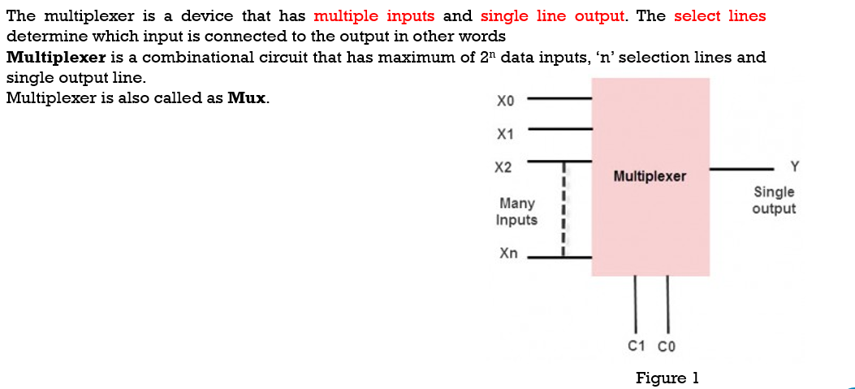

4x1 Mux Contd.
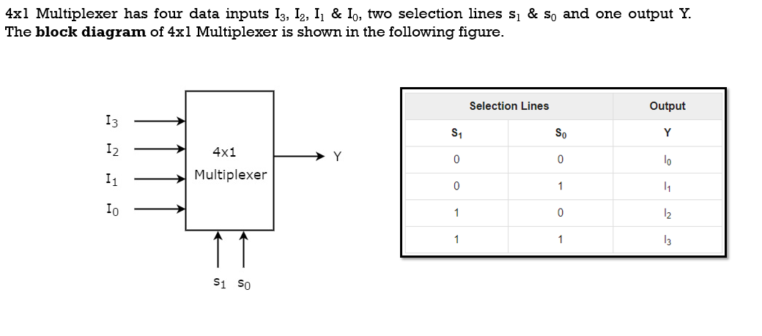
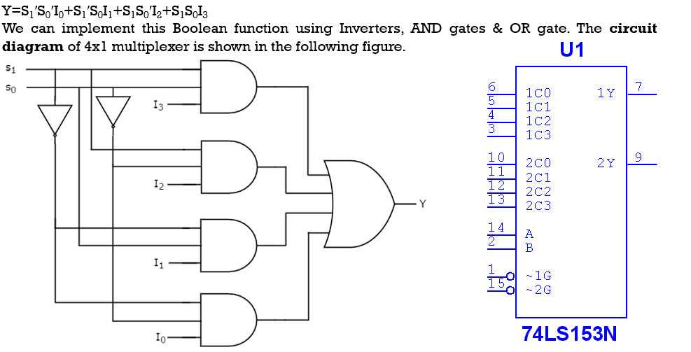

4x1 Mux(74LS153 Testing in Multisim)
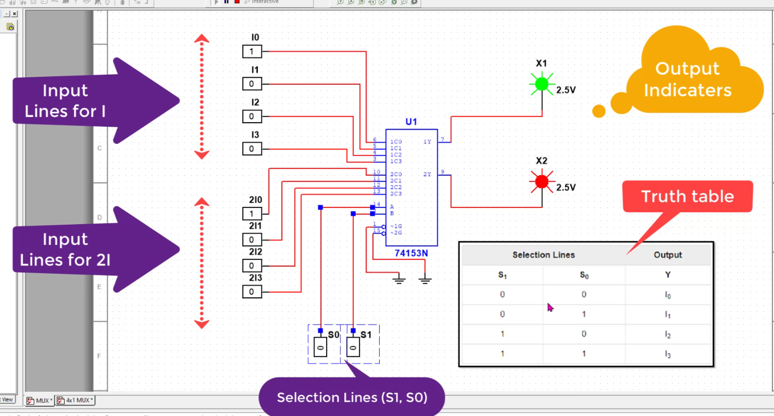

8x1 Mux
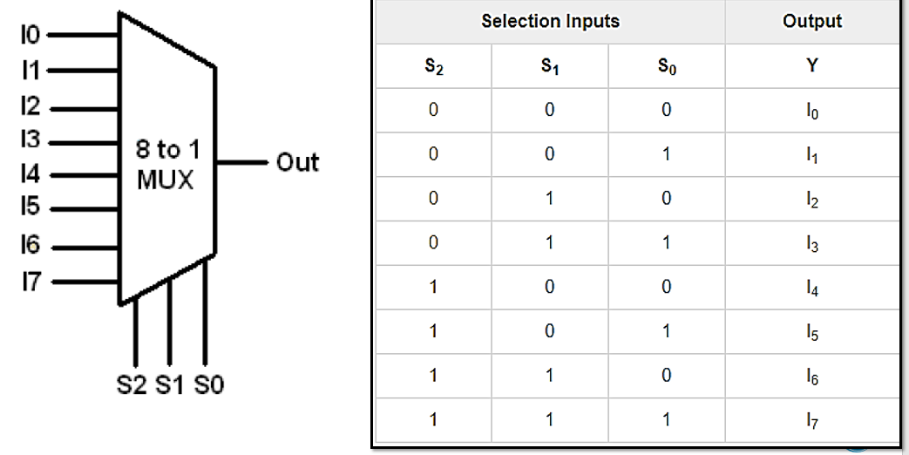

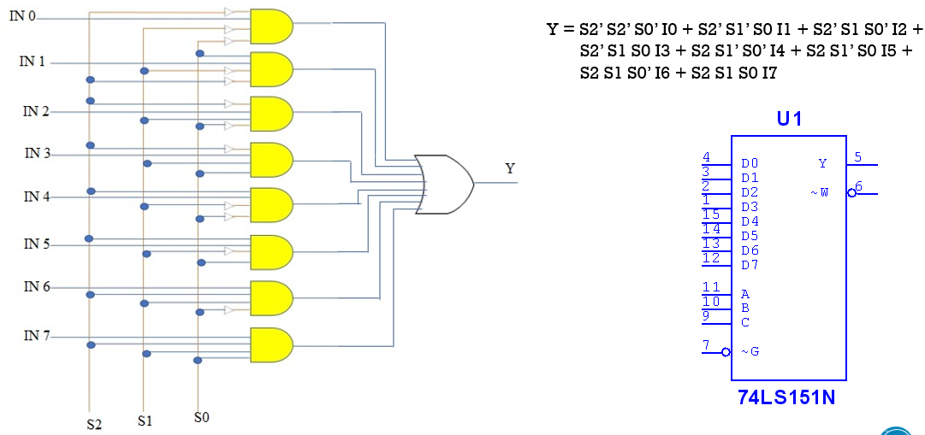

8x1 Mux(74LS151 Testing in Multisim)
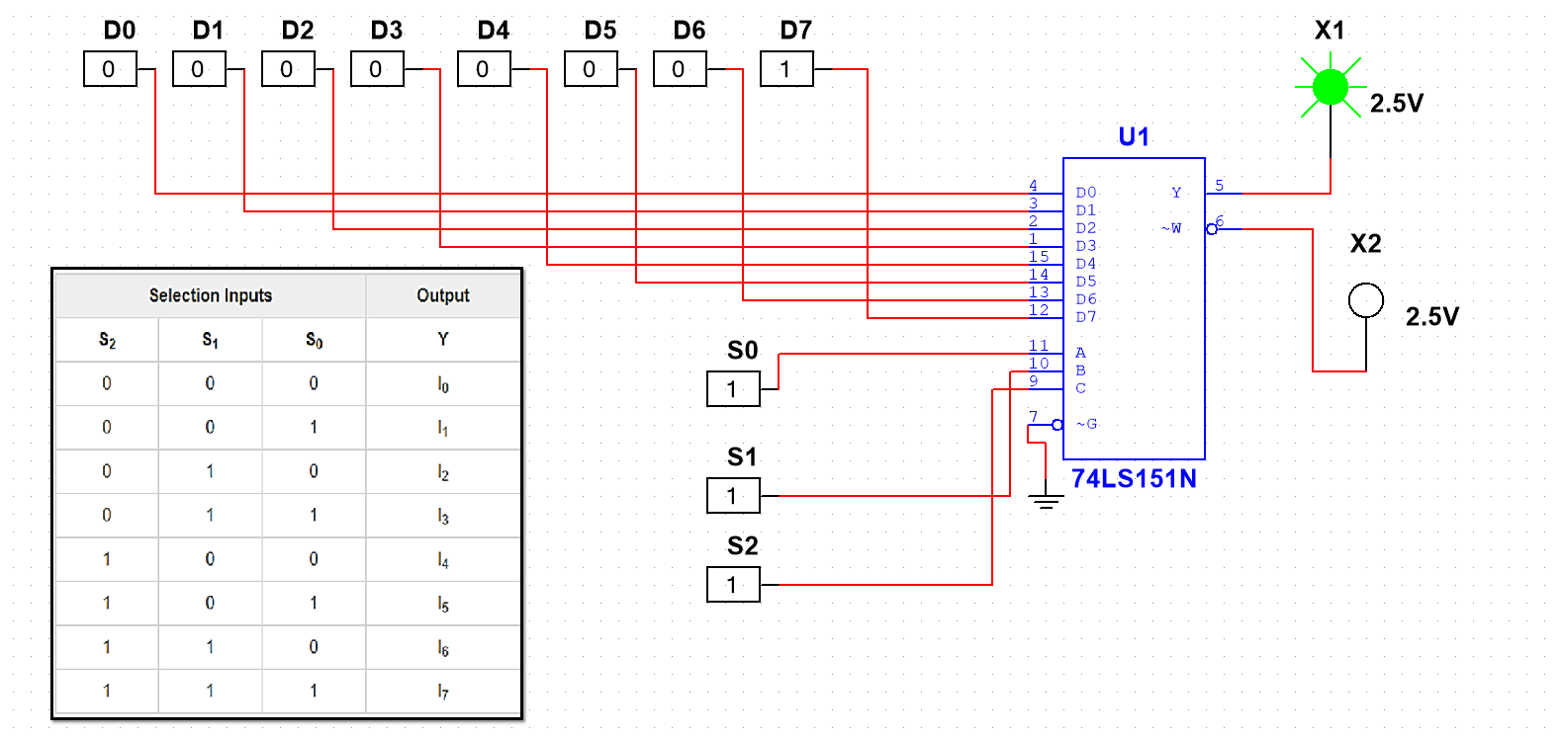

DE Multiplexer
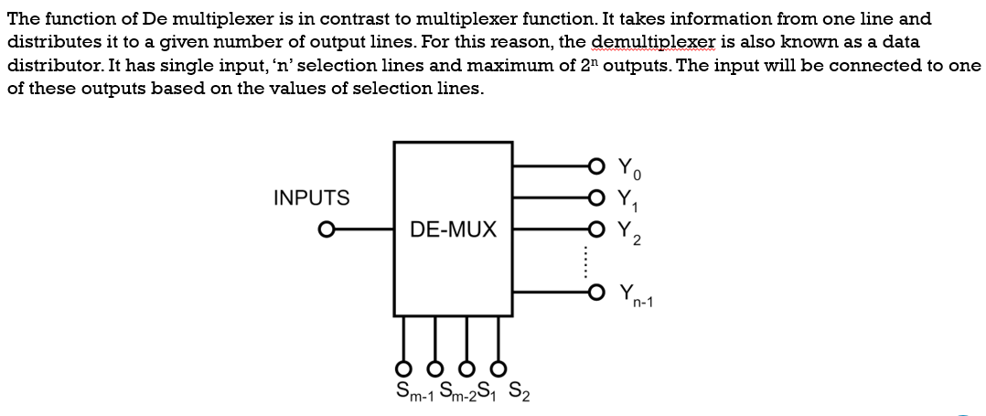

1x4 De Multiplexer
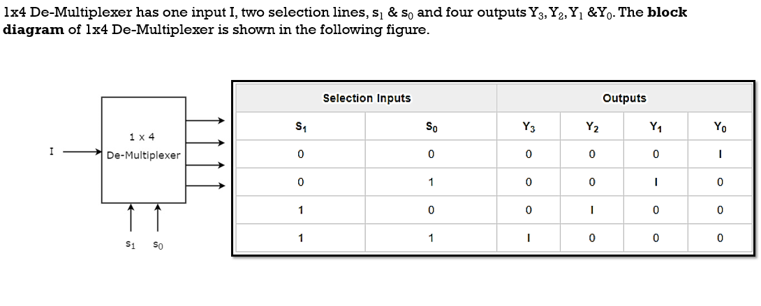

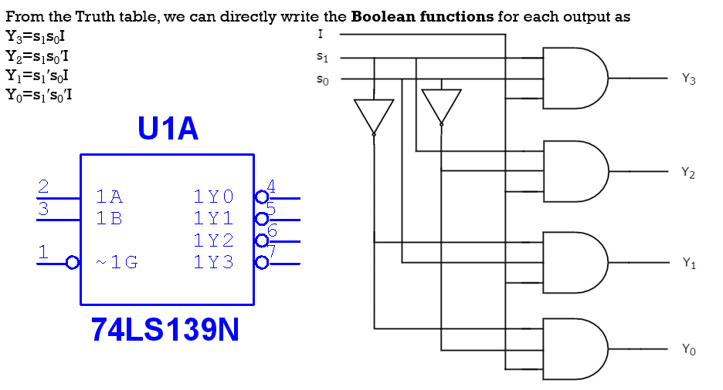

1x4 De-Mux(74LS139 Testing in Multisim)
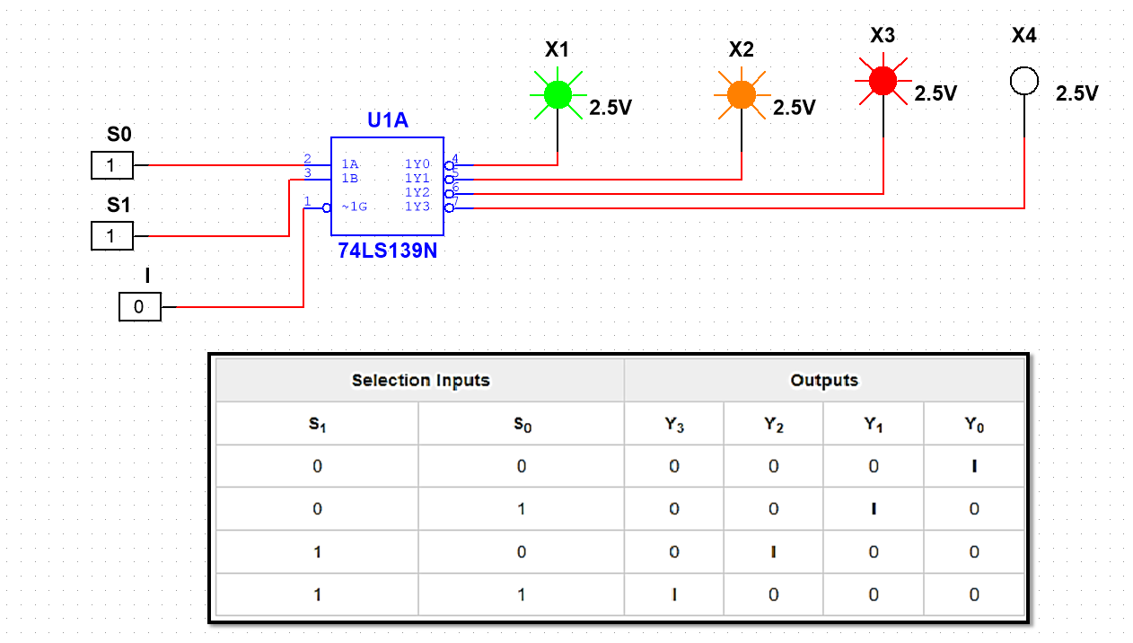

1x8 De Multiplexer
